

BSC (HONS) COMPUTER SCIENCE AND SOFTWARE ENGINEERING

**REFLECTIVE REPORT**

*For*

**Hotel Management System with AI Chatbot Project**

**For**

**Hotel Willow Lake**

|  |  |
| --- | --- |
| **Student Name** | G. G. N. N. Edirisinghe |
| **Student ID** | 2337508 |
| **Role** | Project Manager |
| **Group Number** | 12 |
| **Project Executive** | Dr. Yasas Jayaweera |
| **Module Name** | Social and Professional Project Management |
| **Module Code** | CIS015-3 |
| **Submission Date** | 23rd of August 2024 |

**Table of Contents**

**1.** **Introduction** 1

**2.** **Reflection** 1

**2.1.** **Description** 1

**2.2.** **Feelings** 2

**2.3.** **Evaluation** 2

**2.4.** **Analysis** 3

**2.5.** **Conclusion** 4

**2.6.** **Action Plan** 4

**Appendices** I

**Appendix A – Project Details** I

**Appendix B – Documentation and Trello Board** I

# 

# **Introduction**

This reflective report presents a detailed analysis of my experience as the project manager of a project that was not just a task, but a mission to develop and deploy a complete hotel management system alongside an AI Chatbot for Hotel Willow Lake. The report aims to assess the different stages of the project, evaluate choices made and challenges faced, and gauge the effectiveness of methods employed, notably PRINCE 2, in bringing about the successful completion of this crucial project.

This was an immense task that required teamwork coordination, complex technical issues management, and meeting customers' desires in a limited time. As a project manager, I had the mandate to ensure that every step from planning to final implementation was considered. This report looks at the leadership strategies used, team dynamics, and lessons learned while reflecting on how it has impacted me personally and professionally.

This report will reflect on key aspects like communication, risk management, and adaptability, providing insights into the project's success and challenges and outlining an action plan for future improvements. I aim to use these reflections to enhance my project management skills, ensuring that future projects are managed with greater foresight, flexibility, and efficiency. Through this detailed analysis, I aim to draw meaningful conclusions that will inform my approach to future projects, making me a more effective and resilient leader.

# **Reflection**

## **Description**

The project, Hotel Willow Lake Management System with AI Chatbot, ran from June 16, 2024, to August 16, 2024. As a result of this two-month project, it was possible to develop an extensive hotel management system that included a user-friendly website and integrated AI Chatbot, which enabled its online presence and eased the process of booking rooms. I oversaw the whole task as a project manager, making sure it was completed within the estimated budget of LKR 142600, slightly below our initial projections, therefore reducing our worries. Our five-member team followed the PRINCE 2 methodology, efficiently managing scope, setting objectives, and meeting tight deadlines.

The primary goal was to create a website that not only allowed users to explore amenities, make room reservations, and book private events, but also provided a seamless and user-friendly experience. The added feature of an AI Chatbot further enhanced the user experience. My responsibilities included overseeing the project and actively participating in developing the user login, sign-up, and profile management features. Additionally, I managed key documentation and contributed to system development. To streamline communication and document management, we used **Google Drive** to upload and maintain all project documents, ensuring that the entire team had easy access to the latest versions. **Task assignments** and tracking were efficiently handled using a **Trello board**, which helped us stay organized and keep track of progress across various project tasks.

We met the client’s expectations even after experiencing challenges such as scope changes, development delays, and technical issues. Through this project, I have been able to enhance my leadership skills and also improve my ability to manage projects better, which makes me very proud of myself because of how hardworking we were as a team, as well as the achievements that followed.

## **Feelings**

At the start of the project, I approached my role as project manager with confidence, fully expecting to lead the team to success. However, as we progressed daily in the project, I encountered a range of emotions. Initially, I felt proud of the team's dedication, but this soon shifted to growing stress as we faced challenges, mainly the steep learning curve, due to the team's unfamiliarity with the chosen technologies. This added pressure on me to support the team in learning new skills while keeping us on track with tight deadlines.

The stress intensified during sprint 2 when we experienced delays at the start of the development process. The pressure to make up for lost time was overwhelming, especially knowing that we had to work overtime in sprint 3 to meet our deadlines. While I was impressed by the team's commitment, I constantly needed to ensure our efforts were effective and sustainable. The situation became even more challenging when the client requested a scope change in sprint 4, which conflicted with our timeline. This increased my anxiety, but I managed to work closely with the team to adjust our plans and refocus our efforts.

Throughout the project, feedback from the project executive during board meetings, as well as client meetings, played a crucial role in shaping our approach. The constructive criticism helped refine our work, while positive feedback boosted the team morale. Despite the stress of meeting client demands and navigating complex feedback, we successfully completed the project under budget 142,600 LKR. This achievement, in particular, was a testament to our team's dedication and hard work. In the end, the sense of accomplishment was profound, knowing that we had delivered a quality product that met the client's needs. This experience taught me valuable lessons about leadership, resilience, and maintaining composure under pressure, leaving me with a strong sense of pride and satisfaction.

## **Evaluation**

Several factors contributed to its success and challenges throughout the project. The key element that drove us forward was our team members' strong communication and collaboration. We held two stand-up meetings every week, at the start and end of the week, to discuss the progress, address issues, and make decisions collectively, which fostered a positive team dynamic. The PRINCE 2 methodology provided a clear framework that helped us stay focused and organized on the objectives, ensuring the possibility of navigating the project's complexities with a structured approach.

The main highlight of the project was the successful development of the website's key features. The user interfaces were well-designed, and the booking system worked smoothly, ensuring a seamless guest experience. In addition, integrating an AI Chatbot was a big deal since users could get immediate assistance. Nonetheless, it had some obstacles, too. Due to unanticipated technical problems and the unfamiliarity of the team with these platforms, there were long delays during the development phase. These delays led the team to work overtime, which added stress and fatigue among the team members.

Managing the scope of the project was another area where I faced difficulties. As the project was progressing, a small change in the scope was requested by the client, leading to an alteration in our timeline. While I was eager to accommodate the requests, the changes placed a bit of additional pressure on the team. However, the team's adaptability and quick response to the changes ensured that the project went well and came in under budget. This experience reinforced the need for managing time efficiently, maintaining constant communication with clients and dealing with risks that may have been anticipated.

## **Analysis**

Reflecting on our hotel management system project, my role as the project manager required a good balance between leadership, accountability, and adaptability. From the start of the project, I understood the responsibility on my shoulders to ensure the project's success. This involved making good decisions, managing the risks, and guiding my team through the various challenges. Navigating the unexpected hurdles, such as the delay in the second sprint due to the team's unfamiliarity with the chosen technologies, tested my leadership abilities. During that period, keeping the team motivated and focused under pressure was crucial, but I now see that I could have been more proactive in identifying potential risks earlier. For example, recognizing the steep learning curve associated with new technologies might have allowed us to mitigate the issues before they arose.

During the entire project, adaptability played an essential role, especially when the client requested a change of scope in sprint 4. These changes presented additional challenges, requiring me to work closely with the team to adjust our time plans and meet the client's expectations. This showed me the importance of flexibility and being open-minded enough to consider other alternatives, especially in dynamic projects where unanticipated problems are expected. Nonetheless, there were instances when I could have listened better to different ideas, for instance, during moments of high pressure while managing the team's workload. By reflecting on this with McGregor's Theory X and Theory Y, we could see that our team was primarily aligned with Theory Y, whereby people were motivated from within, taking responsibility for their work. However, some elements of Theory X surfaced during high-stress periods, indicating that closer supervision and support might have been necessary to maintain motivation.

Regarding the feedback we received, both the input from the project executive and the client played a pivotal role in refining our approach. Our lecturer's positive and negative feedback during the board meetings helped us identify areas of improvement and motivated us to strive for higher standards. Also, the feedback we received from the client boosted morale and reinforced the team's confidence in our work. Managing this feedback required balancing it with the practical realities of project management, ensuring that we could implement suggestions effectively without overextending the team. In conclusion, although I feel I discharged my duties as the project manager to the best of my ability, there are some things that I learned from this experience about leadership, emotional intelligence, and pre-emptively addressing issues before they become critical ones.

## **Conclusion**

In conclusion, managing this project has been an invaluable learning experience that deepened my understanding of leadership and project management. I figured out the ability to navigate challenges, such as changes in scope and technical delays, by fostering open communication and collaboration within the team. However, I recognize areas where I could have been more proactive in risk management and adaptable in my approach. The feedback given by the project executive and the client was of great importance in modifying our work while the project finished within budget; however, it has shown that combining technical expertise with emotional intelligence and foresight is essential. Generally speaking, this project taught me how to encourage a team despite setbacks and achievements, as these experiences are necessary for my future.

## **Action Plan**

Reflecting on this project, I discovered some key areas where I can focus on future improvement. First, I plan on enhancing my skills in dealing with risks by developing a more detailed risk assessment process at the project’s outset. This will include anticipating potential challenges, such as the team’s familiarity with chosen technologies, and planning a contingency plan to address the issues before they become obstacles. By conducting more frequent and thorough risk reviews, I aim to catch problems earlier and reduce the likelihood of delays or scope changes that impact the timeline and the allocated resources.

Another area I aim to improve is my adaptability as a project manager. I plan to achieve this by embracing more flexible approaches to problem-solving and team management. In future projects, I will encourage the exploration of alternative solutions and foster a more collaborative decision-making environment, especially when unexpected scope changes arise. I also recognize the importance of maintaining team motivation and morale during high-pressure periods. I will offer more support and recognize their efforts, as I believe this is crucial for effective team performance. These improvements will help me lead more effectively, ensuring that both the project and the team can thrive even in challenging circumstances.

# 

# **Appendices**

## **Appendix A – Project Details**

* Client: Mr. K. A. D. L. Dilshan Kodippili
* Project Executive: Dr. Yasass Jayaweera

Team Details:

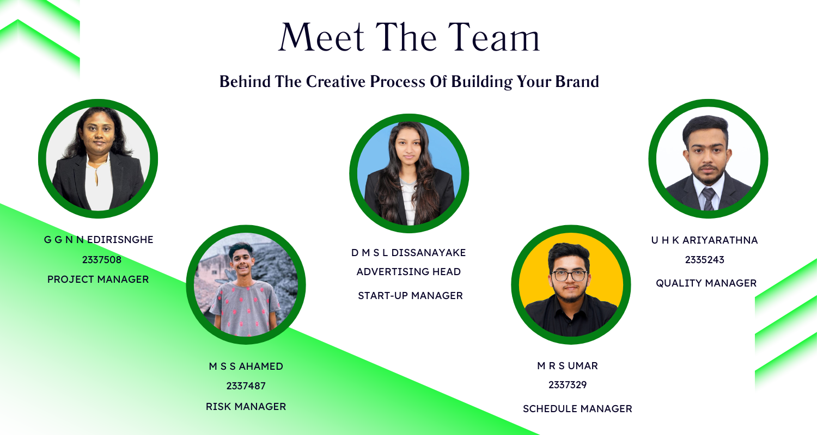

Figure : Team Member Details

## **Appendix B – Documentation and Trello Board**

The reports I made and all the relevant work to the project is submitted in Documentations submission to the BREO. Below I have provided the link to access the documentations.

<https://breo.beds.ac.uk/ultra/courses/_61994952_1/outline/assessment/_8803138_1/overview?courseId=_61994952_1>

The link to access the Google Drive and the Trello board is given below:

Group 12 Google Drive Link:

<https://drive.google.com/drive/folders/10nhkB3oY0GLB4T87OugVGpCVhUzb3cMU>

Group 12 Trello Board Link:

<https://trello.com/b/DSpaG7q8/sppm-g12>

Trello Board Images:

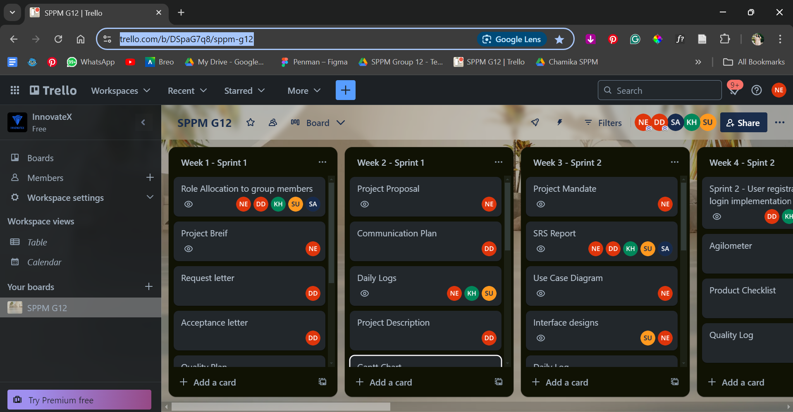

Figure : Trello Board Image 1

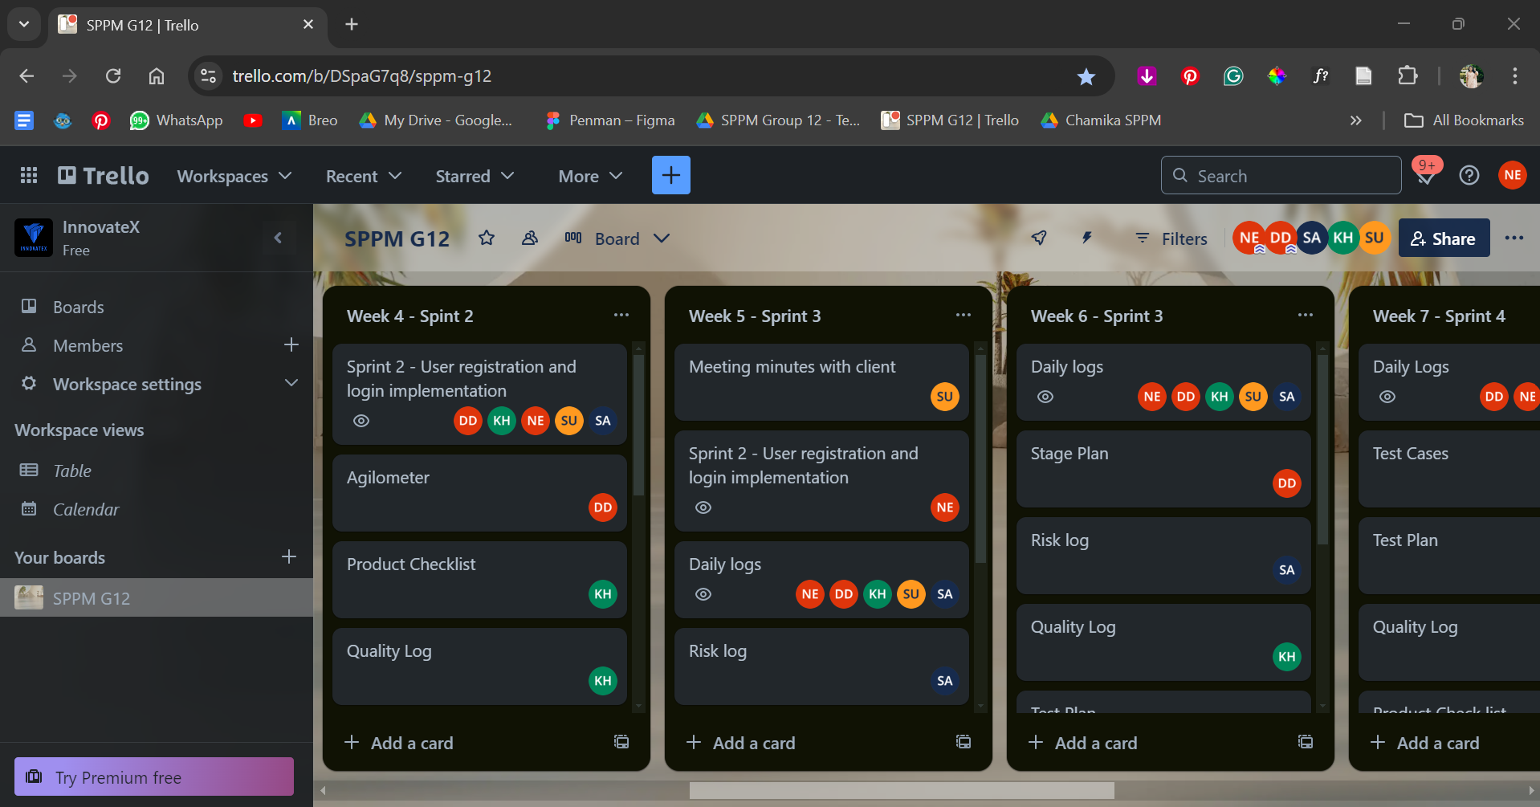

Figure : Trello Board Image 2

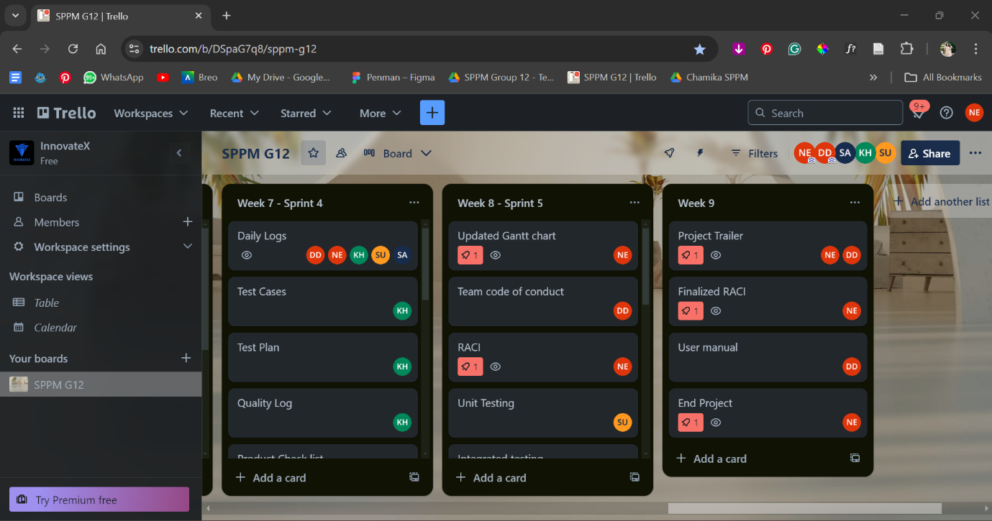

Figure : Trello Board Image 3